



2026 Employee Benefits- Vinylmax Ohio


Welcome To Your Employee Benefits Program

At Vinylmax Windows we recognize our ultimate success depends on our talented and dedicated workforce. We understand the contribution each employee makes to our accomplishments and so our goal is to provide a comprehensive program of competitive benefits to attract and retain the best employees available. Through our benefits programs we strive to support the needs of our employees and their dependents by providing a benefit package that is easy to understand, easy to access and affordable for all our employees. This brochure will help you choose the type of plan and level of coverage that is right for you.

You can also view overviews of our benefit plans by accessing our website, www.vinylmax.com/benefits.

Sincerely,

Sylvia McGuire


Table of Contents

Welcome To Your Employee Benefits Program 2
Eligibility 3
Medical Options – What’s the difference? 4
Express Scripts Prescription Coverage 7
Medical Mutual Mobile App 8
Find a Provider 9
Smart Shopper 10
Sword Chronic Pain Program 11
Health Savings Account 13
Dental Insurance 15
Vision Insurance 16
Life and AD&D 17
Voluntary Life AD&D Offering 17
Disability Insurance 18
Worksite Products 18
Employee Assistance Program (EAP) 19
Flexible Spending Accounts 20
Contact Information 21



Eligibility

Eligible Employees:
You may enroll in the Vinylmax Windows Employee Benefits Program if you are a Full-Time employee, salary or hourly, working at least 30 Hours per Week.

Eligible Dependents:
If you are eligible for our benefits, then your dependents are too. In general, eligible dependents include your spouse, and children up to age 26. If your child is mentally or physically disabled, coverage may continue beyond age 26 once proof of the ongoing disability is provided. Children may include natural, adopted, stepchildren, and children obtained through court- appointed legal guardianship.

When Coverage Begins:

The effective date for your benefits is January 1, 2026. Newly hired employees and dependents will be effective in Vinylmax Windows’s benefits programs 30 days from the date they are hired. All elections are in effect for the entire plan year and can only be changed during Open Enrollment unless you experience a family status event.

Family Status Change:
A change in family status is a change in your personal life that may impact your eligibility or dependent’s eligibility for benefits. Examples of some family status changes include:

- Change of legal marital status (i.e., marriage, divorce, death of spouse, legal separation)
- Change in number of dependents (i.e., birth, adoption, death of dependent, ineligibility due to age)
- Change in employment or job status (spouse loses job, etc.)

If such a change occurs, you must make the changes to your benefits within 30 days of the event date. Documentation may be required to verify your change of status. Failure to request a change of status within 30 days of the event may result in your having to wait until the next open enrollment period to make your change. Please contact Human Resources to make these changes.

Note: Some states (currently, California, Massachusetts, New Jersey, Rhode Island, Washington D.C., and Vermont) may impose a tax on residents who do not have health insurance coverage, subject to limited exceptions.


Medical Options – What’s the difference?
Vinylmax Windows will offer medical plans through Medical Mutual of Ohio. The chart below provides a brief overview of the available plans. For complete details, please refer to the Summary Plan Description.
If you need help finding a provider, visit: https://providersearch.medmutual.com
- Ohio and Northern Kentucky: SuperMed Network
- Outside Ohio: Cigna PPO Network
 | Medical Mutual  HDHP HSA |  | Medical Mutual  PPO
 | In-Network Benefits | Out-of-Network Benefits | In-Network Benefits | Out-of-Network Benefits
Annual Deductible
Individual | $5,000 | $10,000 | $4,000 | $10,000
Family | $10,000 | $20,000 | $8,000 | $20,000
Coinsurance | 80% | 50% | 70% | 50%
Maximum Out-of-Pocket*
Individual | $6,750 | $20,000 | $7,900 | $20,000
Family | $13,500 | $40,000 | $15,800 | $40,000
Physician Office Visit
Primary Care | Deductible then 80% | Deductible then 50% | $40 copay per visit | Deductible then 50%
Specialty Care | Deductible then 80% | Deductible then 50% | $60 copay per visit | Deductible then 50%
Preventive Care
Adult Periodic Exams | 100% | Deductible then 50% | 100% | Deductible then 50%
Well-Child Care | 100% | Deductible then 50% | 100% | Deductible then 50%
Diagnostic Services
X-ray and Lab Tests | Deductible then 80% | Deductible then 50% | Deductible then 70% | Deductible then 50%
Urgent Care Facility | Deductible then 80% | Deductible then 50% | $75 copay | Deductible then 50%
Emergency Room Facility | Deductible then 80% | Deductible then 80% | $300 copay then 70% | $300 copay then 70% after deductible
Inpatient Facility | Deductible then 80% | Deductible then 50% | Deductible then 70% | Deductible then 50%
Outpatient Facility and Surgical | Deductible then 80% | Deductible then 50% | Deductible then 70% | Deductible then 50%
Mental Health
Inpatient | Deductible then 80% | Deductible then 50% | Deductible then 70% | Deductible then 50%
Outpatient | Deductible then 80% | Deductible then 50% | $40 copay | Deductible then 50%
Substance Abuse
Inpatient | Deductible then 80% | Deductible then 50% | Deductible then 70% | Deductible then 50%
Outpatient | Deductible then 80% | Deductible then 50% | $40 copay | Deductible then 50%
Retail Pharmacy (30 Day Supply)
Generic (Tier 1) | Deductible then $5 copay | Deductible then $5 copay | $10 copay | $10 copay
Preferred (Tier 2) | Deductible then $40 copay | Deductible then $40 copay | $65 copay | $65 copay
Non-Preferred (Tier 3) | Deductible then $105 copay | Deductible then $105 copay | $125 copay | $125 copay
Preferred Specialty (Tier 4) | Deductible then $250 copay | Deductible then $250 copay | $250 copay | $250 copay
Mail Order Pharmacy (90 Day Supply)
Generic (Tier 1) | Deductible then $12.50 copay | Not covered | $25 copay | Not covered
Preferred (Tier 2) | Deductible then $100 copay | Not covered | $162.50 copay | Not covered
Non-Preferred (Tier 3) | Deductible then $262.50 copay | Not covered | $312.50 copay | Not covered
Preferred Specialty (Tier 4) | Deductible then $625 copay | Not covered | $625 copay | Not covered

Employee Contributions (Weekly)
PPO Weekly Non-Tobacco Employee Contribution
Employee | $64.97
Employee & Spouse | $142.94
Employee & Child(ren) | $116.95
Family | $194.91
PPO Weekly Tobacco Employee Contribution
Employee | $74.97
Employee & Spouse | $152.94
Employee & Child(ren) | $126.95
Family | $204.91
HDHP HSA Weekly Non-Tobacco Employee Contribution.
Employee | $56.21
Employee & Spouse | $123.14
Employee & Child(ren) | $100.83
Family | $167.76
HDHP HSA Weekly Tobacco Employee Contribution.
Employee | $66.21
Employee & Spouse | $133.14
Employee & Child(ren) | $110.83
Family | $177.76

*Please note: There is a $20/week spousal surcharge.

  - Additional Medical Plan Option 
Vinylmax is continuing to offer an additional Minimum Essential Coverage “MEC” Plan. This is an option to offer low-cost coverage. This is separate from the current UHC major medical plan options. This is not a major medical plan but provides minimum essential coverage for everyday access to healthcare such as copays for office visits, urgent care, x-rays, free preventive care, free and unlimited Teladoc, free mental health services and pharmacy copays when in network. Hospital stays and surgeries are not covered. Not intended for those with chronic conditions.

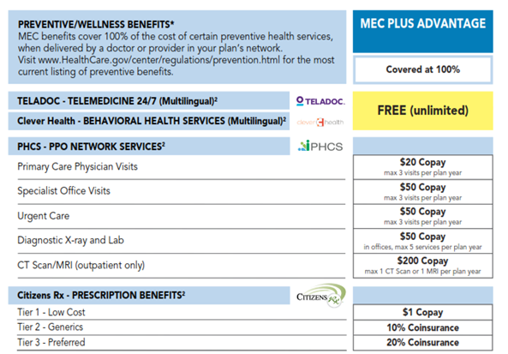

Employee Contributions (Weekly)
Mec Plan Option |  | Non-Tobacco |  | Tobacco
Employee | $10.83 |  | $20.83
Employee & Spouse | $21.88 |  | $31.88
Employee & Child(ren) | $21.88 |  | $31.88
Family | $32.37 |  | $42.37
Note for Open Enrollment: For employees electing to stay with current enrollment it will be a passive open enrollment meaning you do not need to do anything, and Your elections will automatically roll over for 2026 open enrollment.

Express Scripts Prescription Coverage

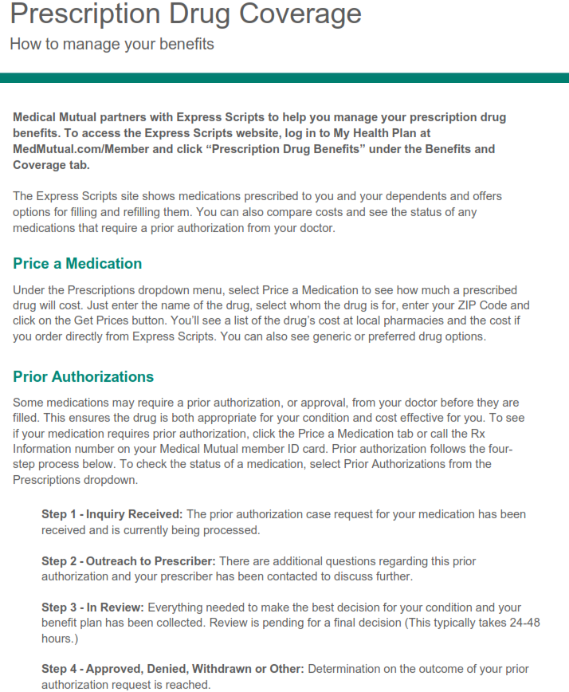



Medical Mutual Mobile App

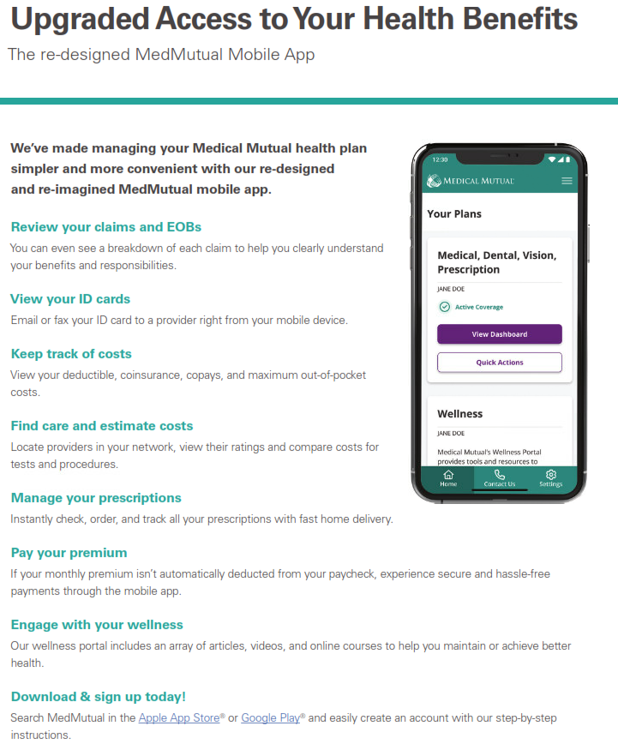

Find a Provider

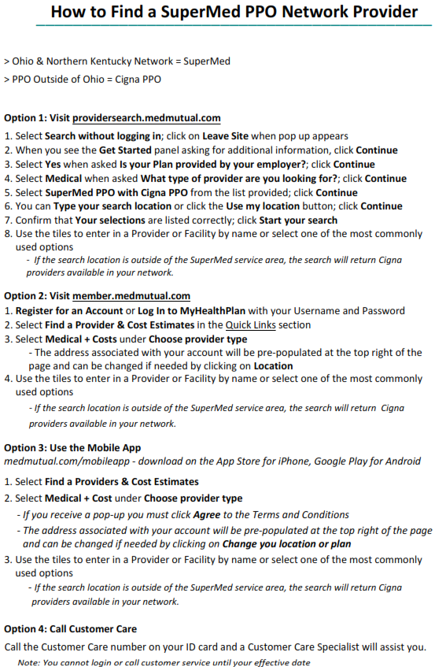

Smart Shopper

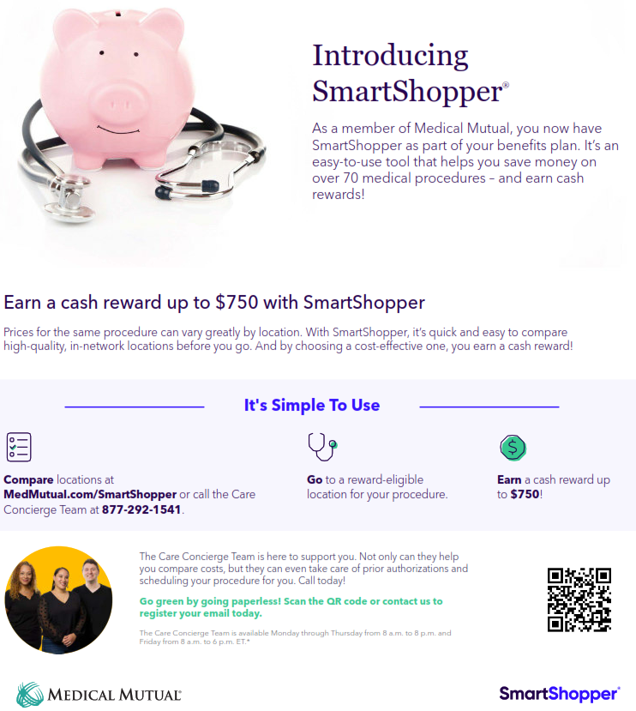

Sword Chronic Pain Program
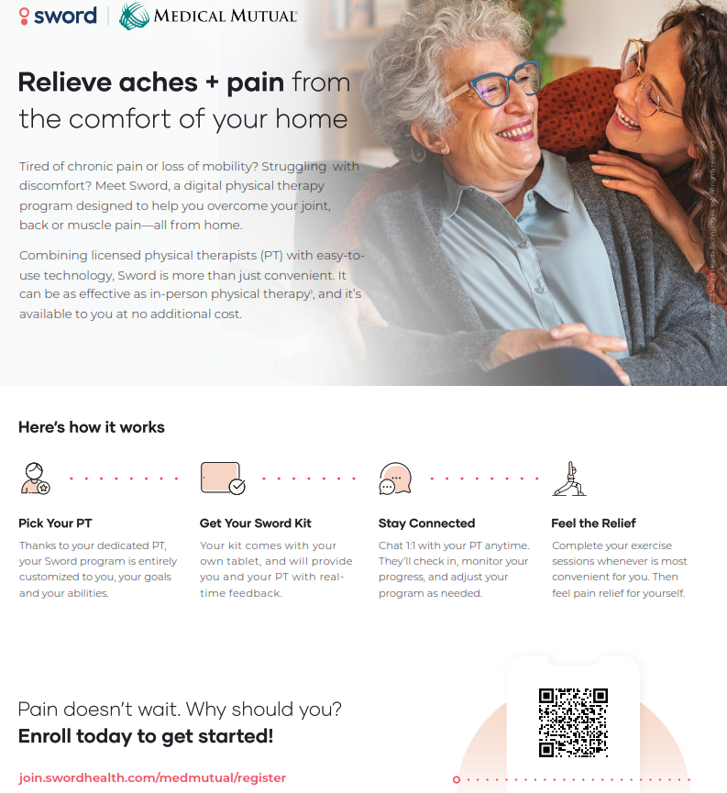

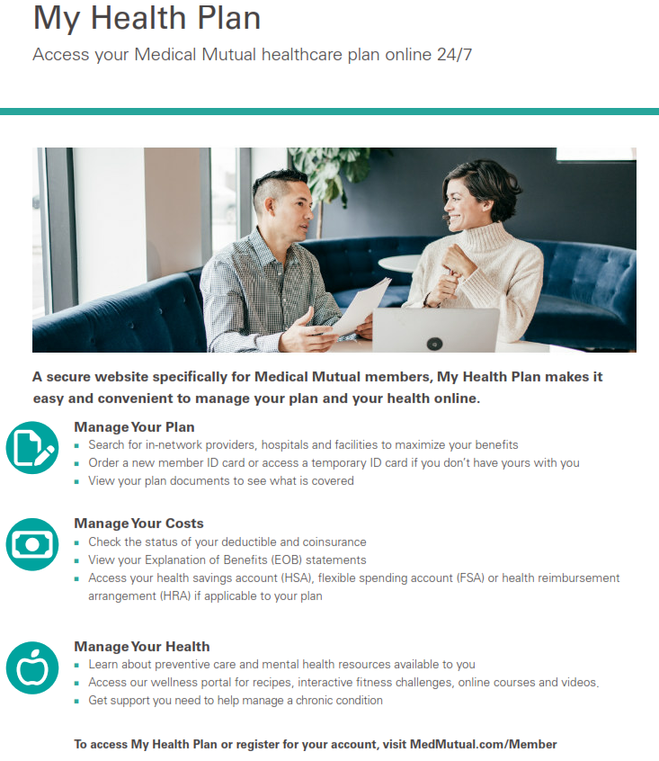
My Health Plan MMO
Wellness

Through Medical Mutual employees have access to Workspring wellness program.

The wellness experience includes:
- Biometric screenings
- Virtual or on-site wellness workshops
- Mental Health First Aid
- Tobacco cessation programs



Health Savings Account
A Health Savings Account (HSA) is a type of account you can use to set aside money to pay for qualified health care expenses. You generally don’t have to pay taxes on money contributed to or withdrawn from an HSA, if the money is spent on a qualified health care expense. When you are enrolled in a Qualified High-Deductible Health Plan (QHDHP) and meet the eligibility requirements, you may open and contribute to an HSA account.

Are you eligible to open a Health Savings Account?
Although everyone can enroll in the Qualified High-Deductible Health Plan, not everyone is eligible to open and contribute to an HSA. If you do not meet these requirements, you cannot open an HSA.

- You must be enrolled in a Qualified High-Deductible Health Plan (QHDHP)
- You must not be covered by another non-QHDHP health plan, such as a spouse’s PPO plan.
- You are not enrolled in Medicare.
- You are not in the TRICARE or TRICARE for Life military benefits program.
- You have not received Veterans Administration (VA) benefits within the past three months.
- You are not claimed as a dependent on another person’s tax return.
- You are not covered by a traditional health care flexible spending account (FSA). This includes your spouse’s FSA (Enrollment in a limited purpose health care FSA is allowed)

The money in the account is yours. If you don’t spend the money in the account, it rolls over to the next year. There is no limit to how much money may be rolled over.
Vinylmax Annual HSA Contributions
Enrollment Contribution | Amount
Employee Only | $600
Employee & Spouse | $1,000
Employee & Child(ren) | $1,000
Family | $1,000
2026 HSA Contribution Limits

You can contribute to your Health Savings Account on a pre-tax basis through payroll deductions up to the IRS statutory maximums. The IRS has established the following HSA maximum contributions for 2026:

- Individual: $4,400

- Family: $8,750

If you are age 55 and over, you may contribute an extra $1,000 catch up contributions.

How You Can Use HSA Funds:

- Dental Care
- Medical expenses not covered by your plan.
- Vision Care
- Prescription Drugs
- Orthodontics
- Over-the-Counter medicine
- Physical Therapy
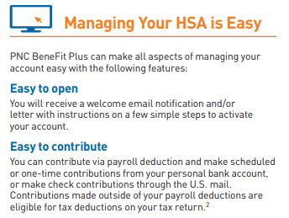

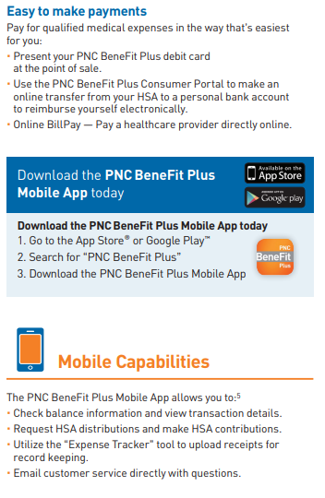
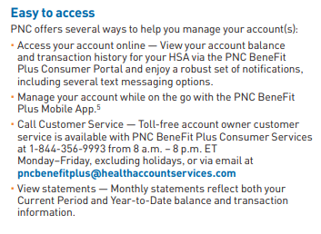

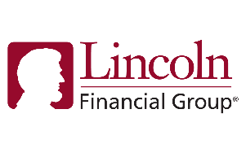
Dental Insurance
Vinylmax Windows will continue to offer a dental program. The chart below is a brief outline of the plan. Please refer to the summary plan description for complete plan details. To find a dentist, please visit this website and login or register to connect to the Lincoln Provider Portal.

Lincoln Financial Group
Dental
 | In-Network Benefits | Out-of-Network Benefits
Annual Deductible
Individual | $50 | $50
Family | $150 | $150
Waived for Preventive Care? | Yes | Yes
Annual Maximum
Per Person / Family | $1,500 | $1,500
Preventive | 100% | 100%
Basic | 80% after deductible | 80% after deductible
Major | 50% after deductible | 50% after deductible
Orthodontia
Benefit Percentage | 50% | 50%
Adults (and Covered Full-Time Students, if Eligible) | Children only | Children only
Dependent Child(ren) | Covered | Covered
Lifetime Maximum | $1,500 | $1,500
Benefit Waiting Periods | First of the month after 30 days | First of the month after 30 days

Employee Contributions (Weekly)
Dental Plan
Employee | $3.32
Employee & Dependents | $8.15



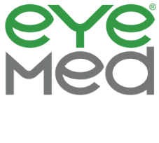
Vision Insurance

Vinylmax Windows provides Vision Insurance through EyeMed. Our vision plan offers in and out-of-network benefits, however, to receive the highest level of benefits, please see an in-network provider. Below is a summary of your benefits. For more information, refer to the summary plan description. To find an eye-doctor, go to eyemed.com.

EyeMed Vision Care
Vision Plan
Copay
Routine Exams (Annual) | $10 copay
Vision Materials
Materials Copay | $25 copay
Lenses | Benefit varies by type of lens. Covered every 12 months
Contacts  Covered in lieu of frames. Medically necessary contacts may be covered at a higher benefit level | Elective contacts covered $0 copay, $130 allowance, 15% off balance over $130 every 12 months
Frames | Covered at $0 copay, $130 allowance, 20% of charge over $130 every 24 months

Employee Contributions (Weekly)
Vision Plan
Employee | $1.49
Employee & Spouse | $2.83
Employee & Child(ren) | $2.98
Family | $4.38



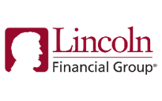
Life and AD&D
Vinylmax Windows provides Employer paid Basic Life and AD&D benefits to eligible employees. The Life insurance benefit will be paid to your designated beneficiary in the event of death while covered under the plan. The AD&D benefit will be paid in the event of a loss of life or limb by accident while covered under the plan.
Lincoln Financial Group
Group Life ADD
Employee
Benefit Maximum | $25,000
Guaranteed Issue | $25,000
Important Reminder!
Be sure to assign a beneficiary or living trust to ensure your assets are distributed according to your wishes.

The Life and AD&D benefits will begin to decrease at age 65.

Voluntary Life AD&D Offering
In addition to the employer paid Basic Life and AD&D coverage, you have the option to purchase additional voluntary life insurance to cover any gaps in your existing coverage that may be a result of age reduction schedules, cost of living, existing financial obligations, etc. Your choice, however, could be subject to medical questions and evidence of insurability. For cost details, please see your summary plan description.

Voluntary Life and AD&D Insurance
You may purchase additional Life insurance with Lincoln Financial Group if you want more coverage. Your contributions will depend on your age and the amount of coverage you elect.
Lincoln Financial Group
Group voluntary Life ADD
Employee
Benefit amount | Increments of $10,000
Benefit Maximum | $500,000
Guaranteed Issue | $200,000
Spouse
Benefit amount | Increments of $5,000
Benefit Maximum | $100,000
Guaranteed Issue | $30,000
Child(ren)
Option 1 Benefit Amount | $100- 14 days to 6 months  $10,000- age 6 months to 26 years
Option 2 Benefit Amount | $100- age 14 days to 6 months  $20,000- age 6 months to 26 years


EOI (Evidence of Insurability) form is required if:
  - You and/or spouse is requesting an amount more than the Guarantee Issue maximum at initial enrollment
  - You and/or spouse is increasing the current level of coverage by more than 2 increments
  - You and/or spouse previously declined coverage and are electing coverage this year

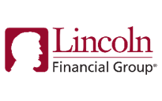
Disability Insurance
Short-Term Disability Insurance
Vinylmax Windows offers a short-term disability option at no cost to eligible team members through Lincoln Financial Group. This benefit covers 60% of your weekly base salary up to $170/week. The benefit begins after 7 days of injury or illness and lasts up to 13 weeks. Please see the summary plan description for complete plan details. Vinylmax also offers a voluntary buy-up option for short-term disability through Lincoln.

 | STD Core | STD Buy-up
Accident Elimination Period | 7 days | 7 days
Sickness Elimination Period | 7 days | 7 days
Benefit Percentage | 50% | 60%
Weekly Benefit Maximum | $170 | $500
Maximum Benefit Period | 13 weeks | 13 weeks

Long-Term Disability Insurance
Vinylmax Windows offers long-term income protection through Lincoln Financial Group in the event you become unable to work due to a non-work-related illness or injury. This benefit covers 60% of your monthly base salary up to $5,000. Benefit payments begin after 90 days of disability. See Certificate of Coverage for benefit duration. Please see the summary plan description for complete plan details. 100% paid by employees if you wish to purchase long-term disability coverage. Offered to salaried employees at no cost.

 | Long-Term Disability
Accident Elimination Period | 90 days
LTD Benefit | 60% up to a monthly maximum of $5,000
Definition of disability | 2-year own occupation
Maximum Disability Period | Social Security Normal Retirement Age
Pre-Existing Condition Limitations | 12 months for conditions treated within 3 months prior to effective date of coverage

Worksite Products
Accident & Injury

No one plans to have an accident. However, it can happen at any moment. Most major medical insurance plans only pay a portion of the bills. Our policy can help pick up where other insurance leaves off and provide cash to cover the expenses. Our accident coverage helps offer peace of mind when an accidental injury occurs outside of the workplace.

Critical Illness

The signs pointing to a critical illness are not always clear and may not be preventable, but our coverage can help offer financial protection in the event you are diagnosed. Lincoln Financial Group voluntary critical illness coverage provides a lump-sum cash benefit to help you cover the out-of-pocket expenses associated with critical illness.

Employee Assistance Program (EAP)
EmployeeConnect through Lincoln offers professional, confidential services to help you, and your loved ones improve your quality of life. When you call the toll-free line, you’ll talk to an experienced professional who will provide counseling, work-life advice, and referrals. All counselors hold master’s degrees, with broad-based clinical skills, and at least three years of experience in counseling on a variety of issues. For face-to-face sessions, you’ll meet with a credentialed, state-licensed counselor.
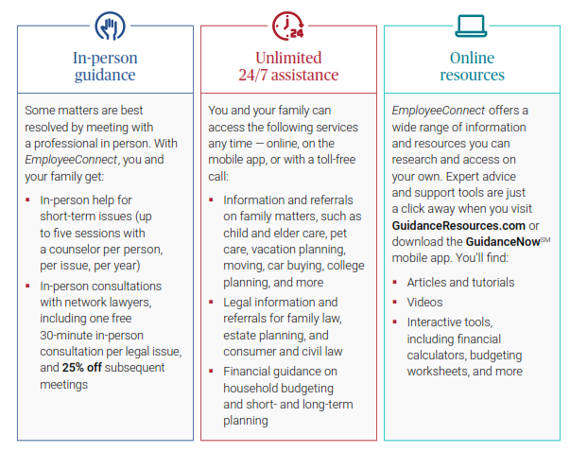

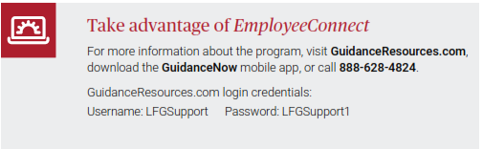


Flexible Spending Accounts
The Flexible Spending Account (FSA) plan with Navia Benefit Solutions allows you to set aside pre-tax dollars to cover qualified expenses you would normally pay out of your pocket with post-tax dollars. The plan is comprised of a health care spending account and a dependent care account. You pay no federal or state income taxes on the money you place in an FSA.

How an FSA works:
- Choose a specific amount of money to contribute each pay period, pre-tax, to one or both accounts during the year.
- The amount is automatically deducted from your pay at the same level each pay period.
- As you incur eligible expenses, you may use your flexible spending debit card to pay at the point of service OR submit the appropriate paperwork to be reimbursed by the plan.

Important rules to keep in mind:
- The IRS has a strict “use it or lose it” rule. If you do not use the full amount in your FSA, you will lose any remaining funds.
- Once you enroll in the FSA, you cannot change your contribution amount during the year unless you experience a qualifying life event.
- You cannot transfer funds from one FSA to another.
- If you do not make your 2026 benefit elections, you will automatically be defaulted to your prior year elections, including the FSA, which will default to your 2025 elections.

Please plan your FSA contributions carefully, as any funds not used by the end of the year will be forfeited. Re-enrollment is required each year.

Maximum Annual Election 2026
Health Care FSA | $3,400
Dependent Care FSA | $7,500 ($3,750 per spouse if separate tax filing)


Popular Uses for FSA Money:
- Dental & Orthodontia
- Prescriptions
- Lasik Surgery
- Glasses

Contact Information
Have Questions? Need Help?
Vinylmax Windows is excited to offer access to the USI Benefit Resource Center (BRC), which is designed to provide you with a responsive, consistent, hands-on approach to benefit inquiries. Benefit Specialists are available to research and solve elevated claims, unresolved eligibility problems, and any other benefit issues with which you might need assistance. The Benefit Specialists are experienced professionals, and their primary responsibility is to assist you.

The Specialists in the Benefit Resource Center are available Monday through Friday 8:00am to 5:00pm Eastern & Central Standard Time at 855-874-0829 or via e-mail at BRCMidwest@usi.com. If you need assistance outside of regular business hours, please leave a message and one of the Benefit Specialists will promptly return your call or e-mail message by the end of the following business day.

Please contact Human Resources to complete any changes to your benefits that are not related to your initial or annual enrollment.

Carrier Customer Service

 | CARRIER | PHONE NUMBER | WEBSITE
Medical | Medical Mutual | 1-800-362-2656 | www.medmutual.com
Health Savings Account | PNC Bank | 1-844-356-9993 | pncbenefitplus@healthaccountservices.com
MEC Plan | The Loomis Compnay | 1-610-374-4040 | info@loomisisco.com
Dental | Lincoln Financial Group | 1-877-275-5462 | www.lfg.com
Vision | EyeMed Vision Care | 1-866-939-3633 | www.eyemed.com/en-us
Life and AD&D | Lincoln Financial Group | 1-877-275-5462 | www.lfg.com
Voluntary Life and AD&D | Lincoln Financial Group | 1-877-275-5462 | www.lfg.com
Short Term Disability (STD) | Lincoln Financial Group | 1-877-275-5462 | www.lfg.com
Long Term Disability (LTD) | Lincoln Financial Group | 1-877-275-5462 | www.lfg.com
Section 125 | Navia Benefit Solutions | 800-669-3539 | www.naviabenefits.com
Voluntary Critical Illness | Lincoln Financial Group | 1-877-275-5462 | www.lfg.com
Voluntary Accident | Lincoln Financial Group | 1-877-275-5462 | www.lfg.com
Employee Assistance Program | Lincoln Financial Group | 888-628-4824 | www.guidanceresources.com


This brochure summarizes the benefit plans that are available to Vinylmax Windows eligible employees and their dependents. Official plan documents, policies and certificates of insurance contain he details, conditions, maximum benefit levels and restrictions on benefits. These documents govern your benefits program. If there is any conflict, the official documents prevail. These documents are available upon request through the Human Resources Department. Information provided in this brochure is not a guarantee of benefits.

